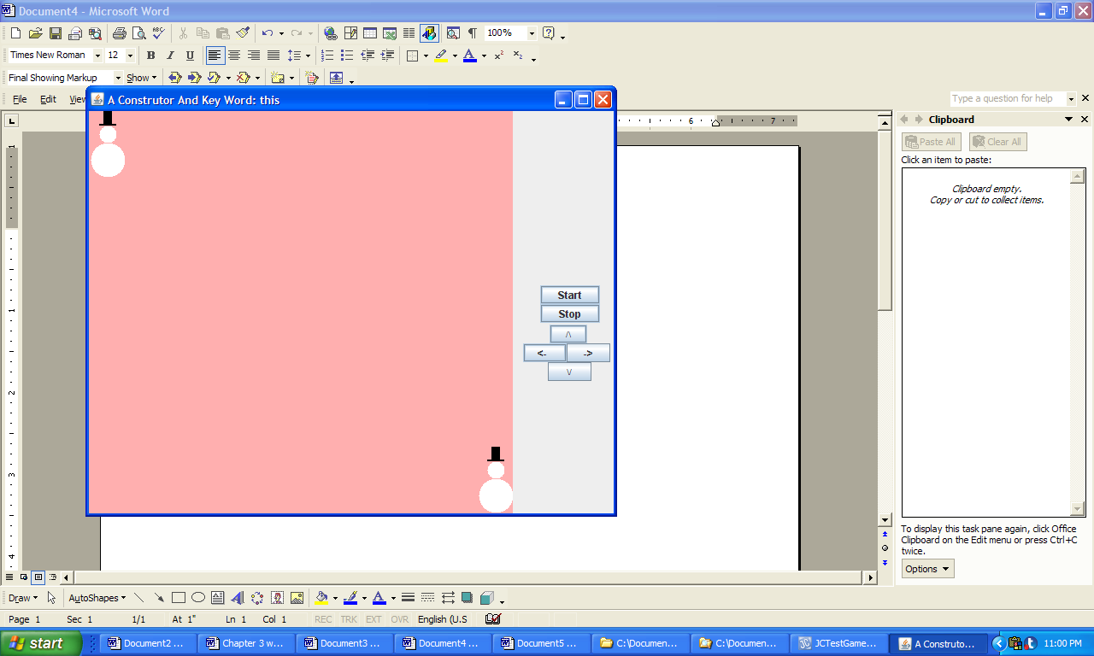

**Figure 3.27 The output from the application ConstructorAndThis.**